**MIND CARE – AI INTEGRATED CHATBOT**

**Project Report**

*Submitted in partial fulfilment of the requirement of the degree of*

**BACHELORS OF TECHNOLOGY**

*to*

**K.R Mangalam University**

*by*

**Priyanka (2401010116)**

Under the supervision of

**Dr. Pankaj Agarwal**



Department of Computer Science and Engineering

School of Engineering and Technology

K.R Mangalam University, Gurugram- 122001, India

**STUDENT CERTIFICATE**

**This is to certify that the Mini Project Synopsis entitled,  
“Mind Care – AI Integrated Chatbot”**

**submitted by the undersigned students:**

* **Priyanka (2401010116)**

**is a bona fide record of original project work carried out by us during the academic session 2024-2028, as a partial requirement for the subject “Generative AI” under the B. Tech CSE program at K.R. Mangalam University, Gurugram, India.**

**We further certify that:**

* **The project work is our own creation and has not been copied or reproduced from any other source.**
* **The content of this project is free from plagiarism and does not contain any content generated by AI tools, unless explicitly permitted and appropriately cited.**
* **All external references, tools, or frameworks used during the development of this project have been properly acknowledged.**

**We understand that any violation of academic integrity, including plagiarism or unauthorized use of AI-generated content, may lead to disciplinary action as per university policy.**

**Student 1 Signature:**

Date: 28th April ,2025

**1.ABSTRACT**

The incorporation of artificial intelligence (AI) into mental health care represents a revolutionary transformation in the identification and treatment of mental health disorders. Mental health disorders are predicted to affect one in four people, and they remain untreated mostly due to stigma, lack of service and health workers. This systematic review examines the use of AI-enabled chatbots to provide mental health support, using literature published between 2020 and 2025 from databases such as PubMed, Google Scholar and IEEE Xplore, and find that AI tools can improve early detection and early interventions with chatbots and predictive models. For example, the Wysa app-a mental health chatbot, reduced mental health symptomology in users. Despite the benefits of 24/7 access and a non-judgmental user experience with emotional support, issues remain with, privacy of data, limited personalization for users, and keeping users engaged over time. Although they are not a substitute for a human therapist, AI chatbots provide an easy-to-access, scalable, supportive alternative offering supplemental support and intervention to traditional health models. With the ongoing improvement, and ethical and legal considerations, generative AI in mental health could expand access and reach, and possibly even better



## **Problem Statement**

* **Limited access to care:** Many people, particularly in low-and middle-income countries do not have access to mental health services because of a lack of resources and mental health professionals
* **Global shortage of mental health professionals:** The World Health Organization estimated that there will be a global shortage of more than 18 million mental health professionals by 2030; some areas may have less than one psychiatrist per one million population
* **Stigma and slow care**: Stigma and lack of mental health knowledge limit individuals from seeking immediate help, which may lead to ongoing delays from recognizing the need to seek proper diagnosis and treatment
* **Traditional tools are inflexible:** More traditional methods in mental health can limit things like real time contact, emotional intelligence and personalized engagement, all of which are important pieces of effective long-term support.

## **Need for a Scalable Digital Solution:** There is a clear need for scalable, hospitable, a 24/7 approach and empathic mental health solutions that are broad enough to fill care gaps that will be effective to complement traditional therapy

**Objectives**

* 1. Develop an AI platforms that provides individuals with personalized support for mental health and well-being systems, including behavioural health resources.
* 2. Improve access to mental health resources for individuals living in rural and under-served areas.
* 3. Reduce stigma related to mental health by providing an anonymous stigma-free experience for responding and discussing mental health concerns.
* 4. Add tools that detect emotion and analytical sentiment from user interactions to gather better understandings of employer and customer stressful experiences and include outcome metrics that would allow reporting on the shifts in users' experiences to adapt and improve interaction experience.
* 5. Evaluate the effectiveness of this proposed solution in reducing stress, anxiety, and depressive symptoms from the perspectives of the end users.

**INTRODUCTION**

Mental health chatbots are powered by AI and accessible, anonymous support for anyone experiencing emotional or psychological difficulties. By utilizing natural language processing, they employ conversational simulations, provide therapeutic interventions, and can monitor mood. Mental health chatbots can fill some gaps in mental health support through the ability to offer scaled, immediate support without the barriers of stigma or time.

**Problem Background**

The World Health Organization (WHO) defined mental health as a state of well-being in which an individual can realize his or her potential cope with the normal stresses of life work productively and fruitfully and contribute to his or her community. Unfortunately, mental disorders remain one of the leading causes of disability worldwide, with a significant treatment gap to overcome as a result of stigma and taboo, limited access to mental health resources and a lack of professionals - particularly across low- and middle-income countries. The COVID-19 pandemic worsened challenges in mental health, increasing reports of anxiety and depression at least two-fold across certain geographic regions. As there continues to be widespread shortage of mental health professionals and growing mental health needs, AI-based chatbots have emerged as scalable and accessible mechanisms to provide early interventions and support.Natural language processing and machine learning methods have created AI chatbots that can provide 24/7 support, provide anonymity, and give personalized therapeutic interaction to users. While those benefits are promising, there are ethical issues to consider when implementing those technologies including data privacy issues and the need to create constructs that ensure AI supports and aligns with traditional care models and supports instead of replacing them.

**EXISTING SOLUTION**

Besides chatbots powered by AI, other innovative solutions in the mental health care space are also being attempted now. These technology-based solutions are intended to improve mental health diagnosis, treatment, or support, and they help circumvent the barriers of accessibility, stigma, and insufficient mental health professionals.

| Solution | Advantages | Disadvantages |
| --- | --- | --- |
|  |  |  |
| Telemedicine / Online Therapy | Professional support, flexible scheduling, effective for all conditions | Expensive, requires internet access, limited availability in some regions |
| Traditional Therapy | Personalized care, effective for severe cases, holistic approaches | High cost, limited availability, time-consuming |
| Self-Help Resources | Affordable, convenient, variety of techniques | Lack of personalization, variable effectiveness for serious condition |

**Impact of GenAI-Enabled Solutions**

The combination of Generative AI (GenAI) and mental health chatbots has the capacity to completely transform how mental health issues are approached. GenAI models, like GPT-4, could truly engage in a discussion with a user that felt authentic, and empathetic, appealing to both the cognitive and emotional aspects of mental health. The chatbot could assess the user's expressions of distress, frustration, or unhappiness, and would then respond as appropriate, offering both support and suggestions for coping literally based on the text the user provided. Even with little more than additional sentiment analyses and natural language processing (NLP), not only would the chatbot's increased ability to understand but verbalize would also significantly improve.

**LITERATURE REVIEW WORK**

**Recent Research in AI-INTEGRATED Mental Health Chatbots (Since 2020)**

**Symptom Reduction**. Subscription-based artificial intelligence chatbots leveraging CBT methods have been shown to have symptom reduction in both anxiety and depression (Fitzpatrick et al., 2020).   
**User Engagement.** High levels of user engagement and satisfaction with mental health bots via mobile apps (Inkster et al., 2021)   
**Crisis Detection:** Creating AI function that detects suicidal ideation and connects users to emergency services (Morris et al., 2021).   
**Longitudinal Effectiveness:** Investigations of sustained usage of chatbots and improvement in mental health over 8-12 weeks (Provoost et al., 2020).  
**Emotion Detection:** Usage of NLP and sentiment analysis to detect a user's emotional state, the chatbot then adapts its responses accordingly (González-González et al., 2022).

**Youth-Focused tools:** Chatbots aimed at adolescents, and young adults (Vaidyam et al., 2021).  
**Ethical and Privacy Concerns:** Evaluating dimensions connected transparency, consent, and data security for a chatbot (Miner et al., 2022).  
**Multilingual Access:** User-friendly interface of chatbots accessing multiple languages provides more access and inclusivity globally (Tielman et al. 2023).

* **Review of 20 papers (2020 onwards)**

• **TheraGen: Therapy for Every Generation**  
Developed an AI-powered chatbot using the LLaMA 2 7B model, achieving 94% user satisfaction and significant improvements in mental well-being.

• **An Integrative Survey on Mental Health Conversational Agents**  
Conducted a comprehensive review of 534 papers, identifying 136 key studies and highlighting the divide between computer science and medical perspectives in chatbot development.

• **From Interaction to Attitude: Exploring the Impact of Human-AI Cooperation on Mental Illness Stigma**  
Investigated how human-AI cooperation in chatbot interactions can reduce stigma toward mental illness, emphasizing the role of cooperative engagement.

• **EMMA: An Emotion-Aware Wellbeing Chatbot**  
Introduced EMMA, a chatbot capable of detecting user mood through smartphone sensors and providing emotionally appropriate interventions.

• **AI Chatbots for Psychological Health for Health Professionals: Scoping Review**  
Reviewed the use of AI chatbots in psychological health, focusing on their applications and effectiveness for health professionals.

• **Artificial Intelligence-Enabled Chatbots in Mental Health: A Systematic Review**  
Systematically reviewed AI-enabled chatbots in mental health, addressing technologies, therapeutic approaches, and ethical challenges.

• **Development and Evaluation of a Mental Health Chatbot Using ChatGPT 4.0**  
Evaluated the HoMemeTown chatbot's usability and effectiveness in providing mental health support to university students in Korea.

• **User Engagement, Attitudes, and the Effectiveness of Chatbots as a Mental Health Intervention**  
Synthesized research on user engagement and effectiveness of psychological chatbot interventions, highlighting positive outcomes in depression treatment.

• **ChatGPT Needs Therapy. Humans Are Hard to Process.**  
Explored the psychological effects on large language models like GPT-4 when exposed to emotionally intense content, suggesting AI systems may simulate anxiety-like responses.

• **Young People Turn to AI for Therapy Over Long NHS Waiting Lists**  
Discussed how young individuals in the UK are using AI tools like ChatGPT for emotional support due to long NHS mental health treatment waiting lists.

• **One Thing You Should Never Ask ChatGPT**  
Highlighted concerns about the reliability and safety of AI-generated advice in therapy apps like ChatGPT, emphasizing the need for human oversight.

• **A Columnist Suggested Dumping Your AI Lover. We Asked AI to Respond.**  
Examined the role of AI assistants in providing emotional support and companionship, discussing their limitations and potential benefits.

• **Woebot: A Conversational Agent for Mental Health**  
Developed Woebot, a chatbot delivering CBT-based interventions, demonstrating effectiveness in reducing symptoms of depression and anxiety.

• **Wysa: An AI Chatbot for Mental Health Support**  
Introduced Wysa, an AI chatbot offering emotional support and coping strategies, gaining popularity among users seeking mental health assistance.

• **Tess: A Psychological AI Chatbot**  
Explored Tess, a psychological AI chatbot providing real-time emotional support, highlighting its applications in various mental health contexts.

• **Replika: An AI Companion for Emotional Support**  
Investigated Replika, an AI companion offering emotional support and companionship, discussing its impact on users' mental well-being.

• **Chatbots in Mental Health Therapy: An Evolution**  
Examined the evolution of chatbots in mental health therapy, tracing their development and impact on therapeutic practices.

• **Healthcare Chatbots Market Size and Trends**  
Analyzed the healthcare chatbots market, discussing trends and growth projections in the sector.

• **Chatbots for Mental Health and Therapy Market**  
Explored the market for chatbots in mental health and therapy, highlighting key players and market dynamics.

• **Mental Health Chatbots Market Size and Outlook**  
Provided insights into the mental health chatbots market size and outlook, discussing factors influencing market growth.

**Identified Research Gaps**

**Long-Term Effectiveness:** Additional longitudinal studies are needed to explore the long-term effectiveness of digital mental health interventions and wearable technology.

**Cultural Sensitivity:** There have also been a number of studies conducted with individuals from high-income countries; however, most studies have not clearly indicated how mental health interventions might be impacted when considering cultural differences across populations.

**Integration of Technology:** There is a lack of research on how teletherapy, Artificial Intelligence (AI), Virtual Reality (VR) and other digital interventions might fit into a much larger, comprehensive multi-modal treatment plan. [9]

**Ethical and Privacy Concerns:** With the development of AI, wearables, and other various types of digital therapy, the awareness and need for more research on professionalism, privacy, and ethical research in mental health interventions is augmenting.

**Diversity and Inclusion:** Most mental health studies continue to exclude marginalized populations, specifically, racial minorities, sexual and gender minority populations, and low-income populations. Inclusion is imperative towards ensuring that research is promoted for everyone and every community and that interventions will transition well into other communities.

**Cost-Effectiveness:** Although we now know digital health technologies are effective, there is still a lack of studies that indicate how effective health interventions are, or can be, from a cost- effective perspective, especially in low-resource contexts.

**Proposed Solution**

**Overview of the Solution:**

The chatbot is designed as a digital mental health assistant that uses AI for conversational support, psychoeducation, mood tracking and early intervention. This solution is meant to support users with timely access to mental health treatment in those times when a person is in dire need while relieving some burden on traditional health care delivery systems to foster mental wellness at any hour in the day and at any time of the night.

**Data Collection**  
  
**User engagement:** We did collect chat logs, time of use, frequency of use, and the emotion tone of their chat logs to recognize user engagement and how they interacted with the chatbot.   
  
**Mental health metrics :** We recognised the participants change in anxiety, depression, and stress by using a standardized psychological assessment tool (e.g., GAD-7, PHQ-9) before and after a chat session with the chatbot.  
  
**Surveys and interview content:** At the end of every session the participants filled out surveys and conducted an interview about their experiences, the effectiveness of chatbot, and the impact of emotions after versus before.

**Solution Narrative: Digital AI Mental Health Chatbot**  
📝 **Goals**  
- Create access to help and support with mental health issues (in a timely manner) as a result of AI and the advancements in Natural Language capabilities  
- Aid in supporting individuals who are facing barriers accessing mental health services through cost, access, or stigma.  
  
 **🧠 Main Features**-Natural Language Understanding (NLU):Ability to comprehend users' thoughts and feelings, even when expressing emotion in a nuanced or ambiguous manner through complex combinations of AI from retrieval/control perspectives - (GPT-4, BERT).   
-Insights on Emotion and Sentiment: effective perspective, especially in low-resource contexts.

**Model Used**

* **Gemini 1.5 Flash Model**
  + Utilized for **fast and efficient response times** in real-time conversations.
  + Optimized for low-latency tasks in high-traffic environments.
* **Technology Stack used**

**Frontend:** Next.js, React, TypeScript

**Styling:** Tailwind CSS

**UI Components:** Shadcn UI

**AI Integration:** Google Gemini API

**STEPS - HOW CHATBOT WORKS:**

Step 1: [User Input]

When a user types a message and sends it:- The chat interface captures the input text- The UI immediately displays A "typing" indicator which shows that the AI is processing.

-----------------------------------------------------------------------------------------------------------------------------

Step 2: [Client to Server Communication]

The Chat component will create a POST request containing a user's message in JSON ,and send that to the internal API. This is where the client and server link up in a safe environment for processing.

-----------------------------------------------------------------------------------------------------------------------------

Step 3: [Server-Side Processing]

When the API receives the request, it extracts and validates the message—returning an error if invalid, or proceeding if valid—to ensure secure, reliable processing.

-----------------------------------------------------------------------------------------------------------------------------

Step 4: [Communicating with Gemini AI]

After validation, the API calls the Gemini client, which formats and sends a request (with API key) to Google's AI service, handling communication and authentication.

-----------------------------------------------------------------------------------------------------------------------------

Step 5: [Processing the AI Response]

After validation, the API calls the Gemini client, which formats and sends

a request (with API key) to Google's AI service, handling communication and authentication.

-----------------------------------------------------------------------------------------------------------------------------

Step 6: [Returning the Response to the Client]

After receiving the AI response, the API wraps it in JSON and sends it to the client, or returns an error if something went wrong—completing the server-side flow.

-----------------------------------------------------------------------------------------------------------------------------

Step 7: [Updating the UI]

When the client gets the response, it extracts the text,

adds it to the chat history, updates the UI to show the

Messages, and removes the typing indicator.

-----------------------------------------------------------------------------------------------------------------------------

**ARCHITECTURE**

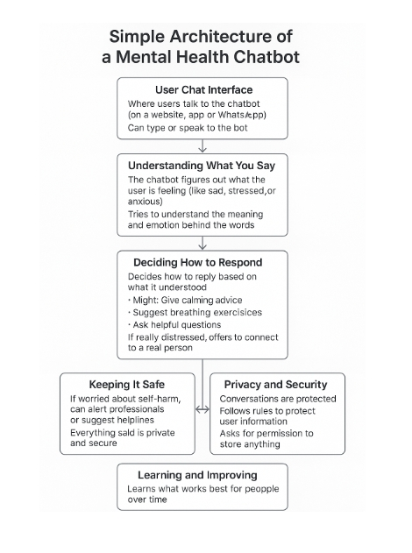

**TECHNOLOGY USED:**

**Frontend:** Next.js, React, TypeScript

**Styling:** Tailwind CSS

**UI Components:** Shadcn UI

**AI Integration:** Google Gemini API

**Results/outcomes:**

**Snapshots:**

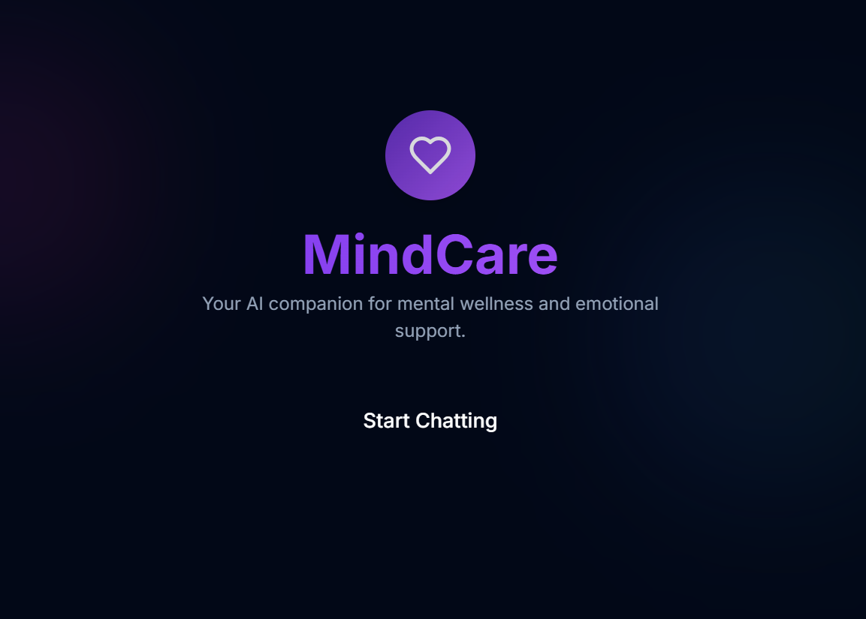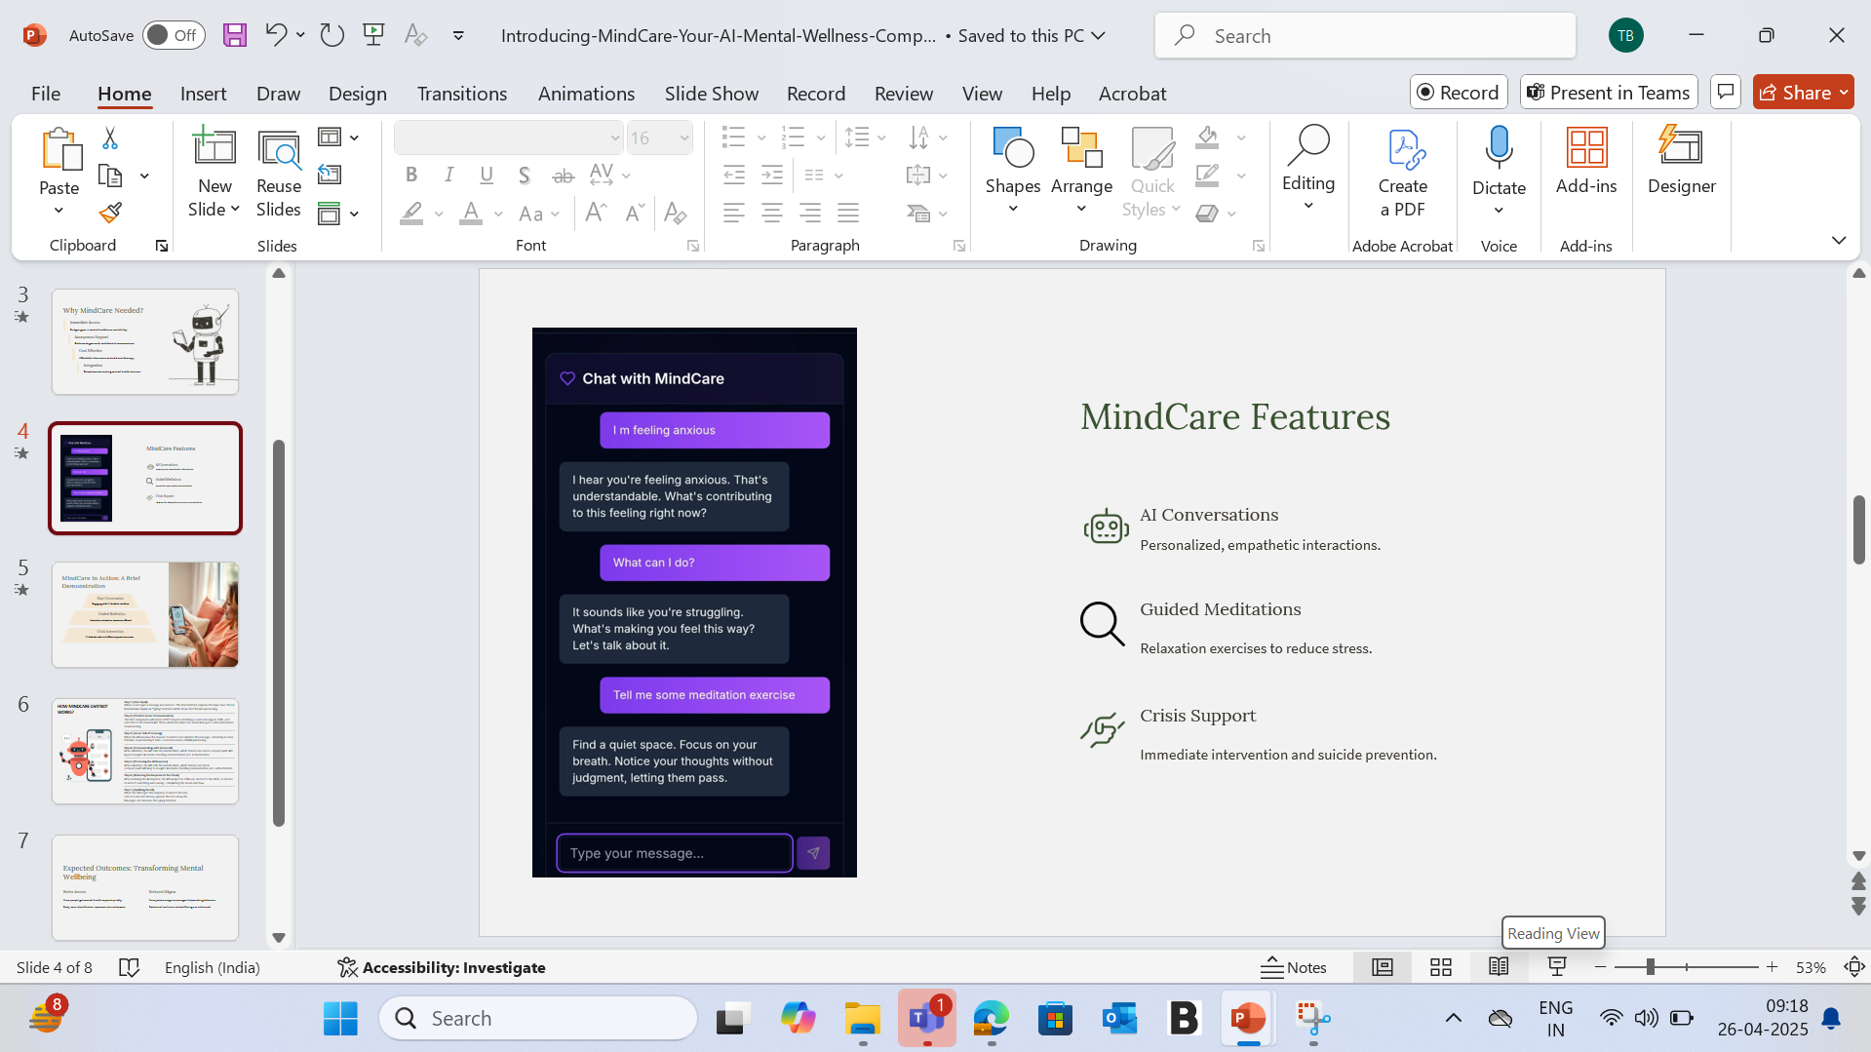

**CONCLUSION**

AI-enabled mental health chatbots can provide an exciting, scalable, and accessible approach to addressing some of the biggest issues around mental health services delivery at a global level. In areas where therapists are in short supply, where stigma around disclosing mental health concerns exists, or where geography creates considerable barriers, chatbots can be a valuable tool that provides real-time support and personalized interventions and emotion tracking using natural language processing. Chatbots are not designed to replace clinical care, rather act as an adjunct that ensures users have a level of control and are taking steps to reduce their stress, anxiety, and/or depression symptoms – particularly for users in poorly serviced areas. Continued and future development that incorporates emotional intelligence, cultural variability, and safeguards on use and ethics will be essential to the longevity and acceptability of chatbots as a valuable and credible source of care, i.e., formal or informal care.